* Linear kernel

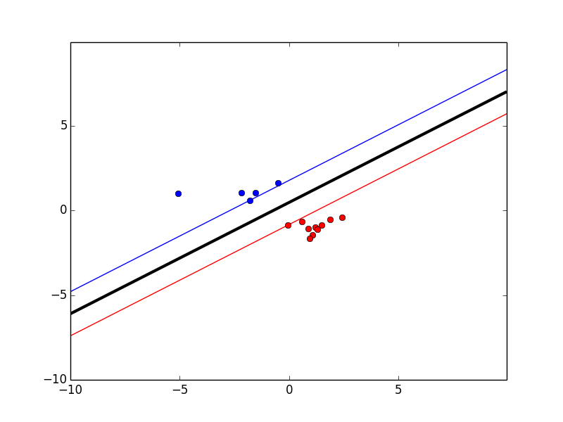

Only good at fitting clearly separable dataset.

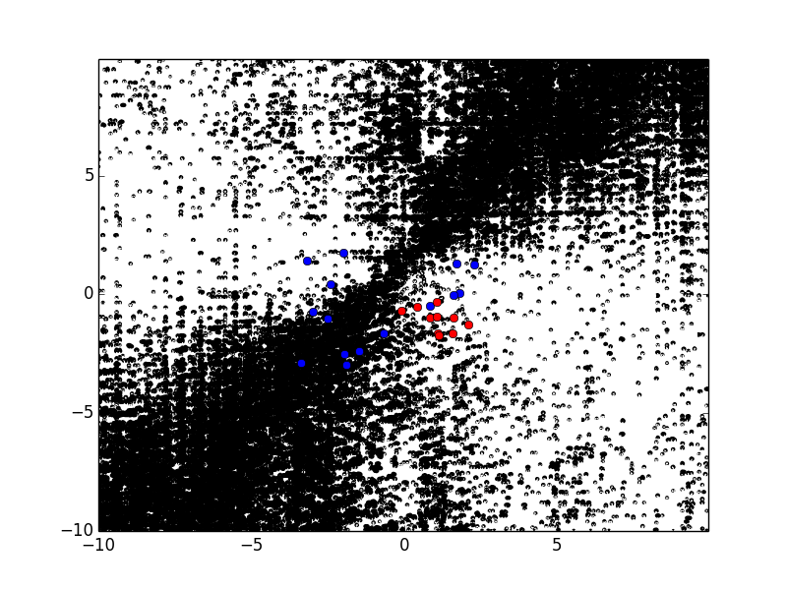

seems linear kernel are awkward in classifying non-linear datasets (terminated KKT)

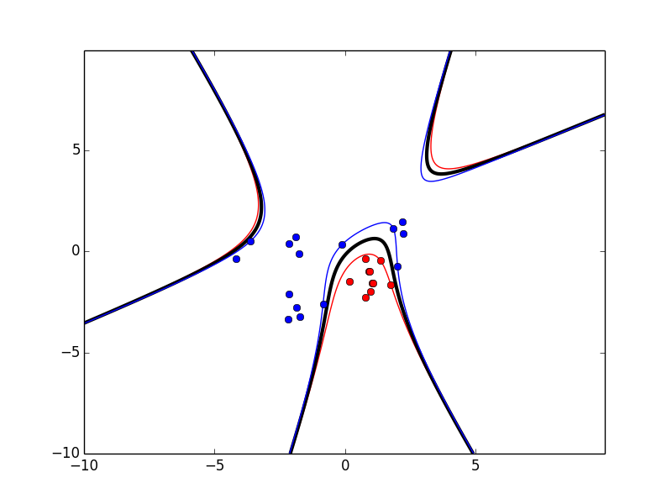

Polynomial kernel for non-linear data, d = 3. Seems still a good seperation

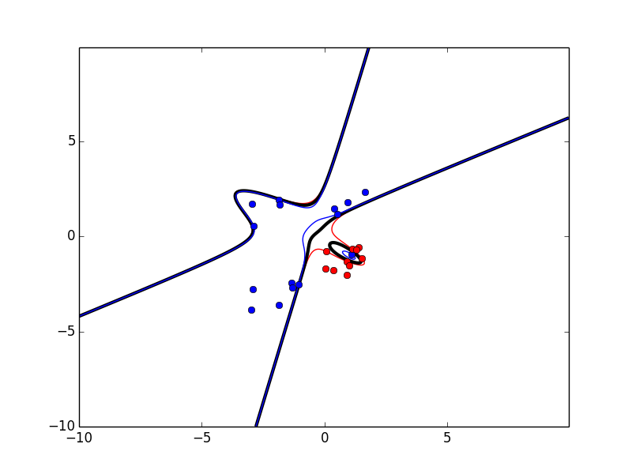

Now d = 4.

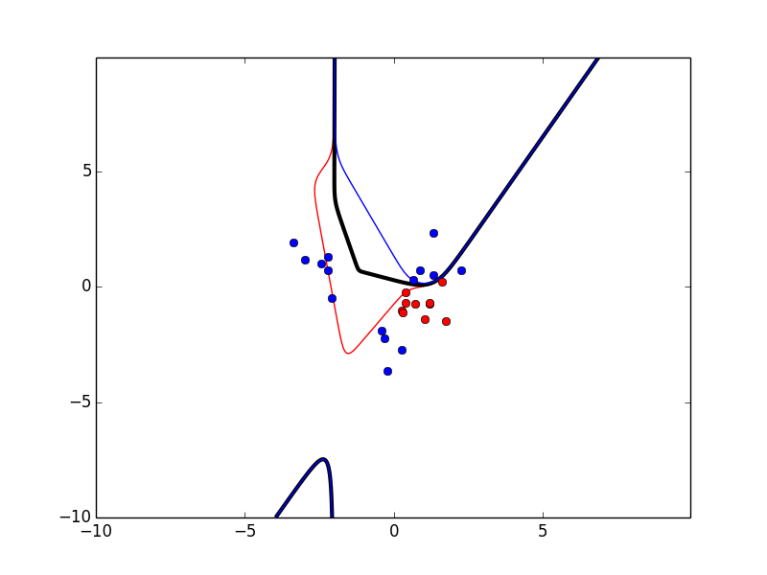

Now d = 10. Overfitting detected.

Conclusion -> with d increases it’s possible to detect overfitting in poly-kernel (better 2)

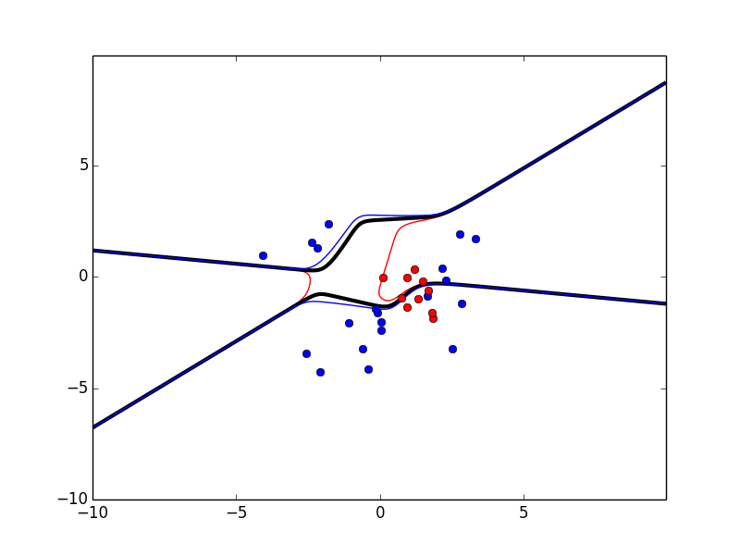

For circular surrounding dataset: d = 10 also causes overfitting

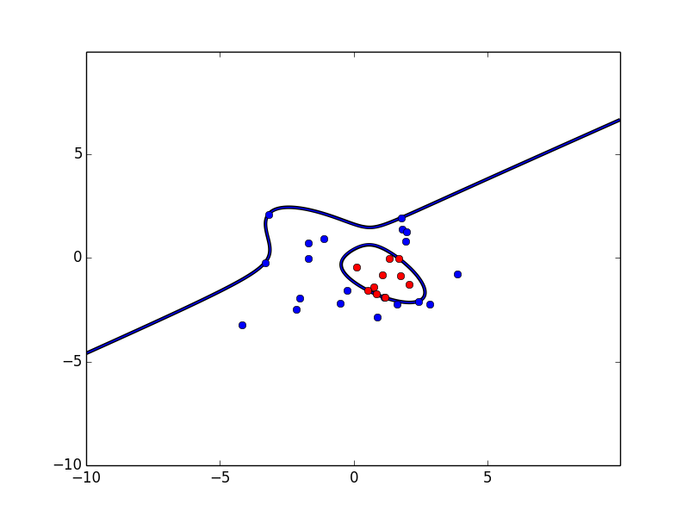

It fits better when d = 3

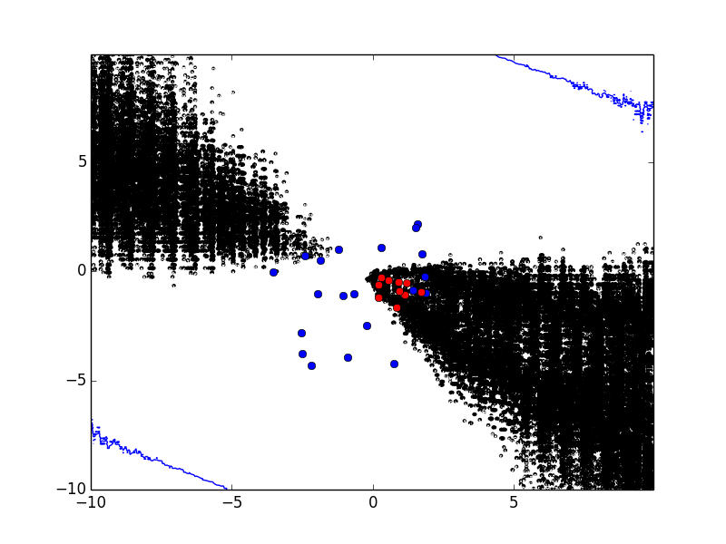

It could not deal with d = 2 (terminated KKT).

* RBF kernel

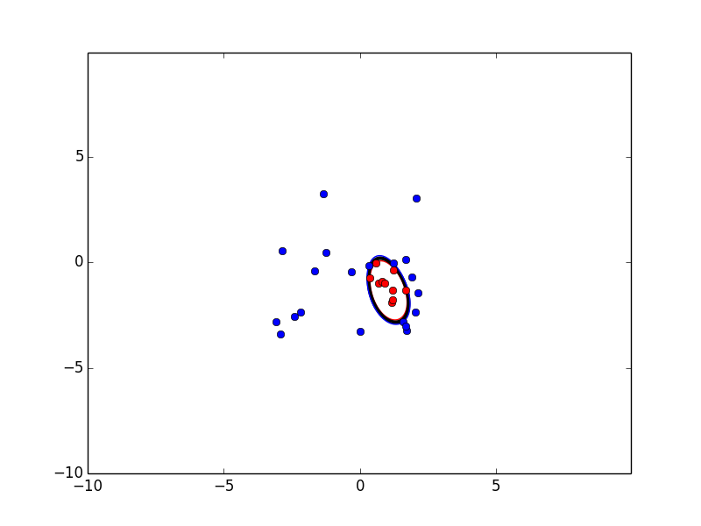

For circular surrounding dataset it could well fit by sigma = 8

Sigma increases -> rigorous the border -> more iterations.

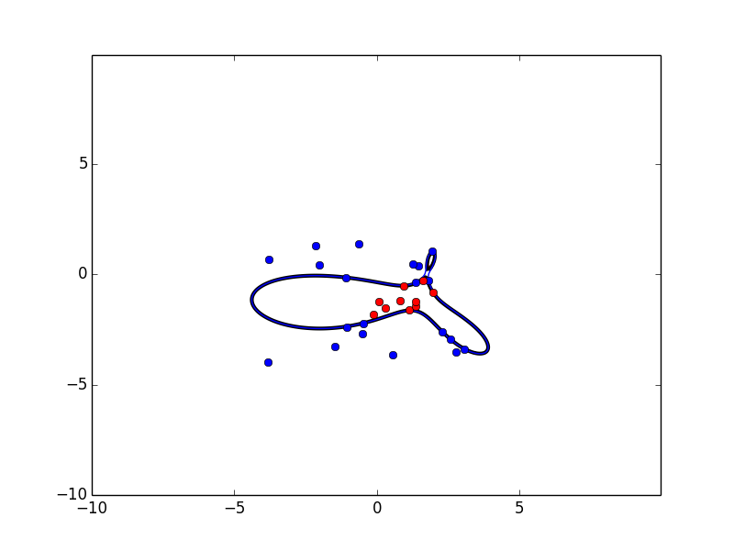

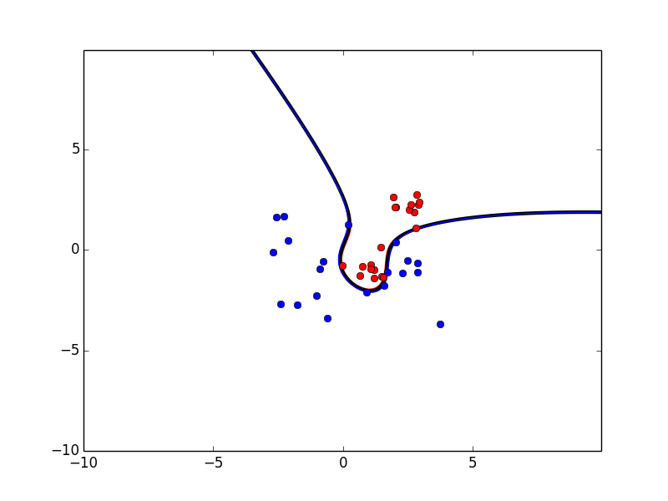

This dataset terminated with sigma = 15.

Moreover adding slack variable is not helpful in RBF kernels (usually leading to very bad result).

